Quick Start Guide

# Prerequisites:

Should be familar with:

1. Git
   1. http://classic.scottr.org/presentations/git-in-5-minutes/
2. Maven
   1. https://maven.apache.org/guides/getting-started/maven-in-five-minutes.html
3. Eclipse
4. Java
5. ImageJ
   1. https://imagej.net/Getting_Started

# Setup Development Environment:

1. Install java and the IDE
2. Visit <https://imagej.net/Developing_ImageJ_in_Eclipse> and follow the directions
3. Clone Imagej
   1. <https://github.com/imagej/imagej>
   2. Windows - open a cmd window
   3. Type C:\ git init
   4. Type C:\ git clone <https://github.com/imagej/imagej.git>
4. Start Eclipse

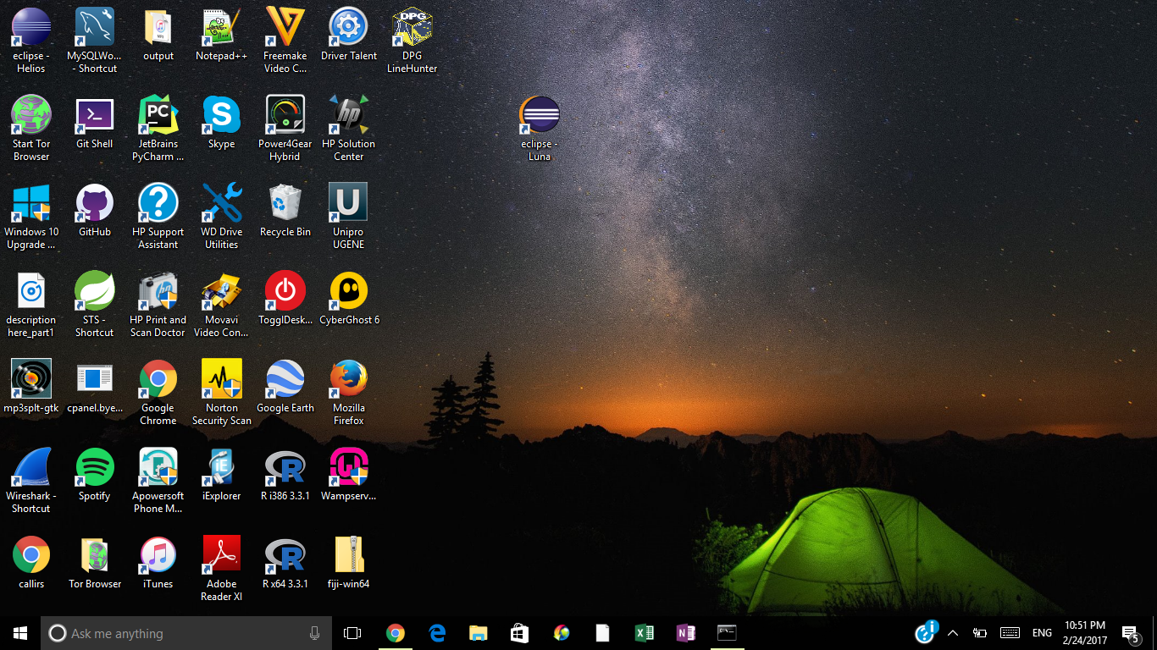

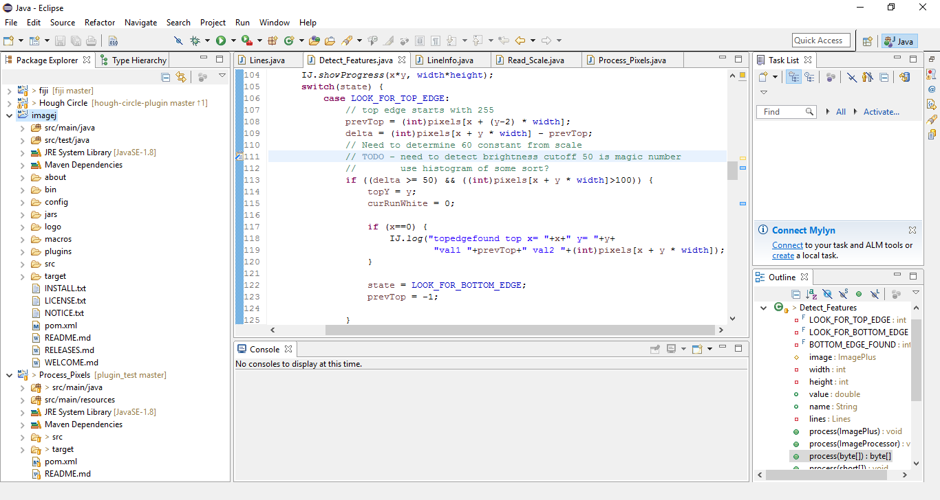

1. Import the imagej clone\
   1. Select File->Import (Choose Existing Maven Project)

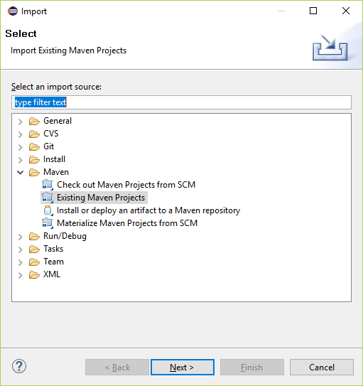

1. Choose the base project

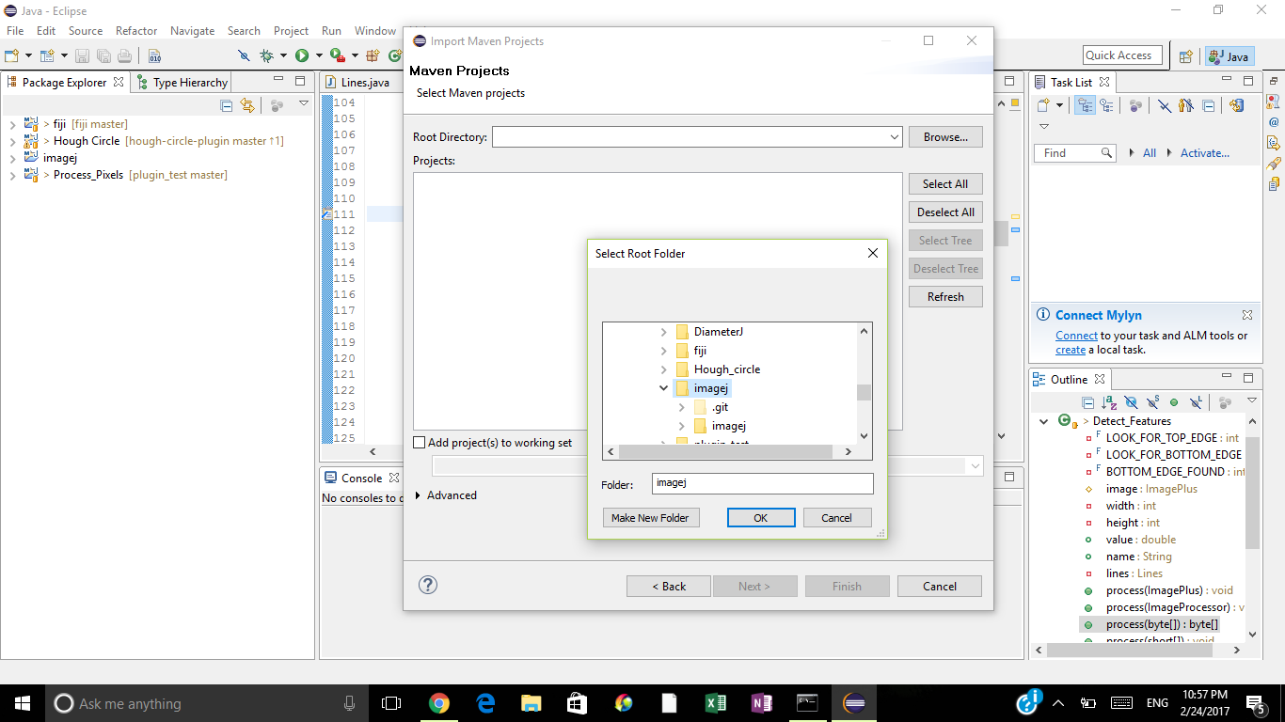

1. Run imageJ.
   1. Right click on package of main

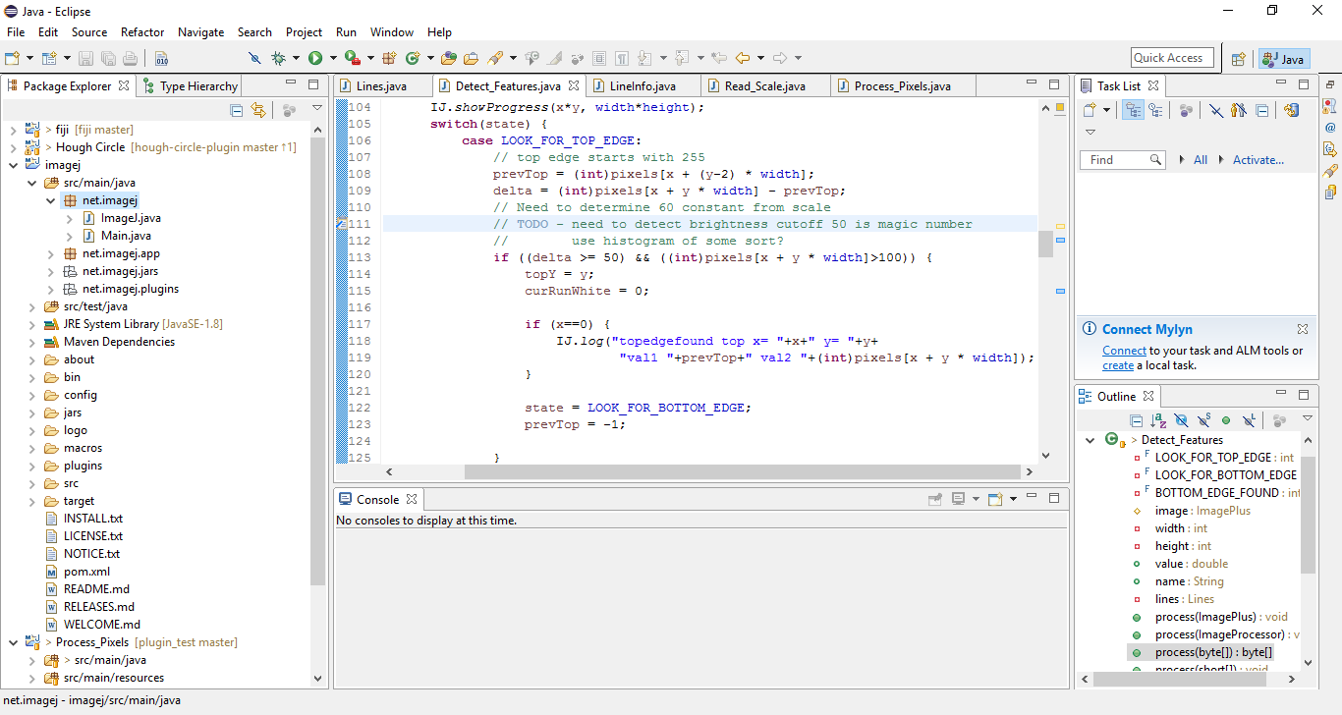

* 1. Click Run As -> Java Application

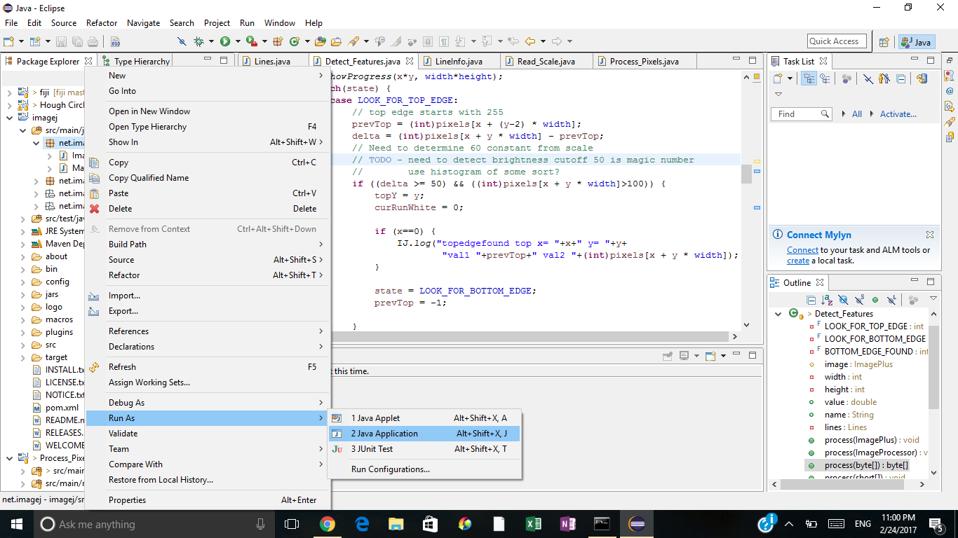

* 1. ImageJ will start up

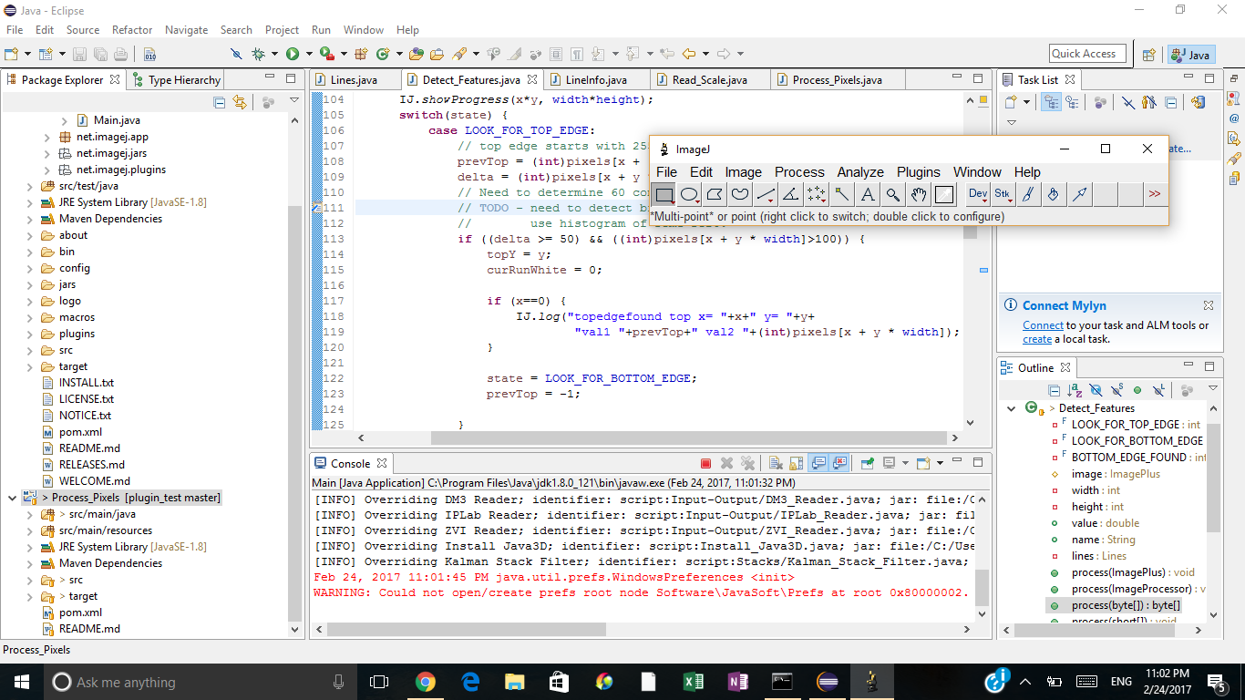

* 1. Clone <https://github.com/jplaschke/webhunter.git>
     1. Follow same instructions as above to create webhunter project
  2. To build. Right click on Process_Pixels->Run As -> Maven Build

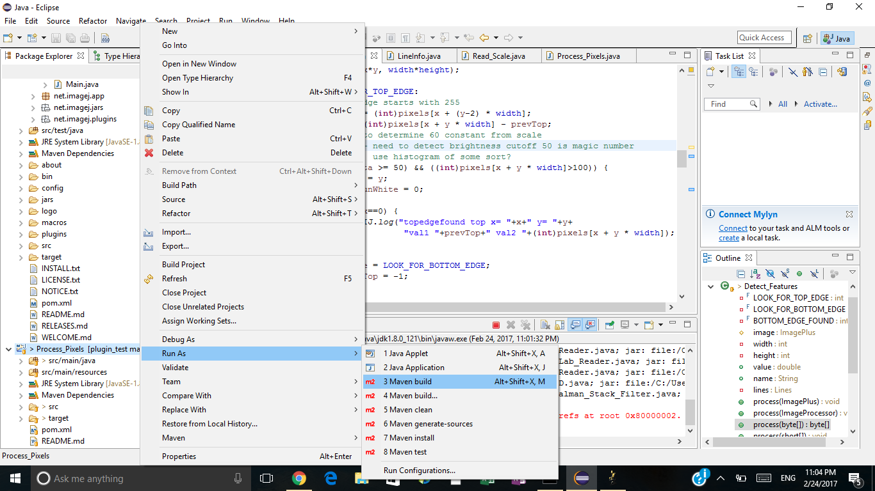

* 1. Set imagej.app.directory to plugin directory of imagej created above

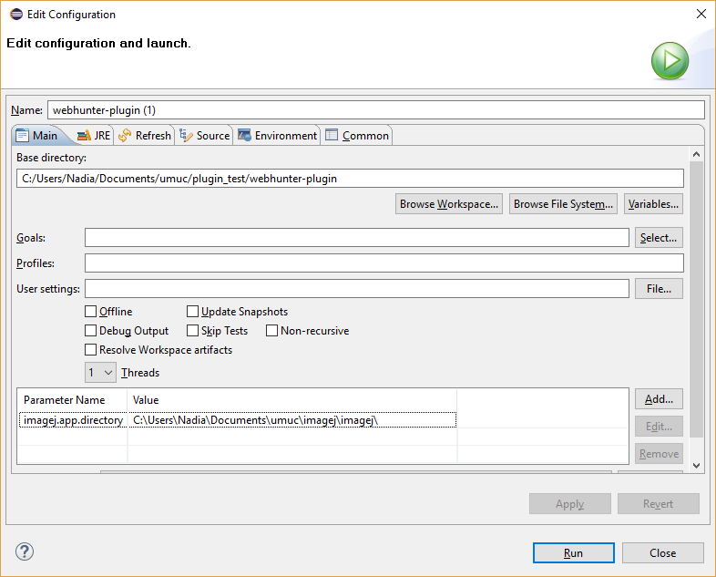

* 1. Should show success
  2. Only have to do this once
     1. Create a file called plugins.config (use your imagej directory) c:\Users\Nadia\Documents\umuc\imagej\imagej\plugins

* + 1. Put the following in the file:

# A single .jar file can contain multiple plugins, specified in separate lines.

#

# The format is: <menu>, "<menu label>", <class name>

#

# If something like ("<arg>") is appended to the class name, the setup() method

# will get that as arg parameter; otherwise arg is simply the empty string.

Process, "Web Hunter", edu.umuc.student.jplaschke.Web_Hunter

Process, "Hough Circle", edu.umuc.student.jplaschke.Hough_Circle

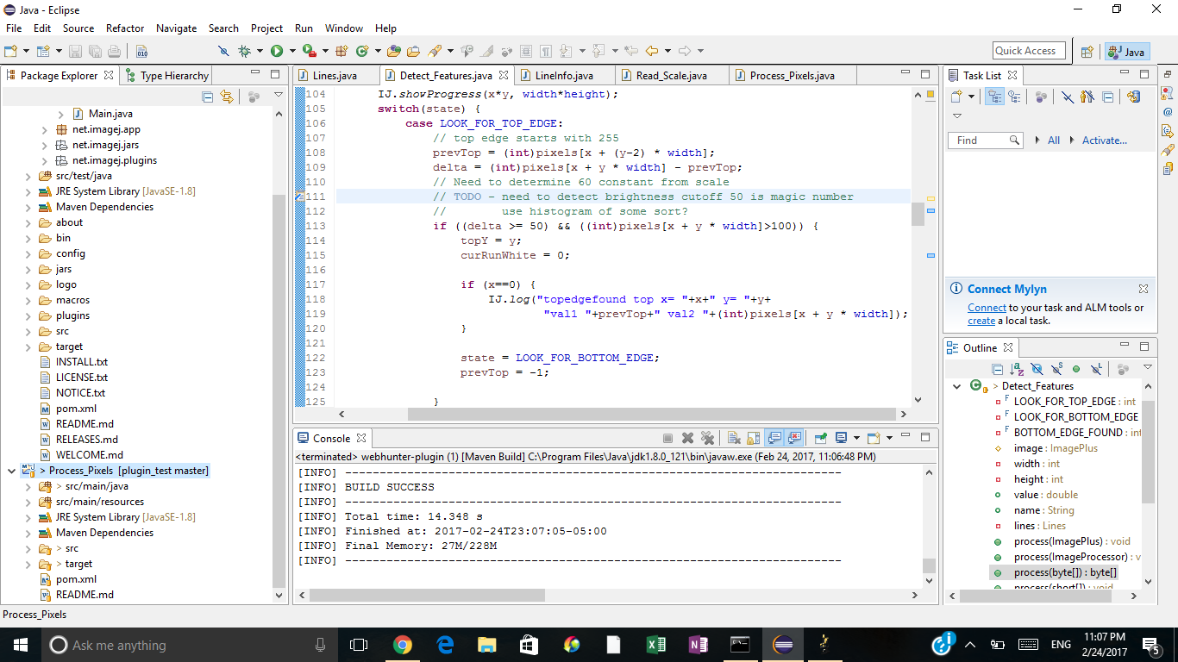

* 1. A jar file, , is created in the imagej.app.directory
  2. Unzip the Process_Pixels-0.1.0.jar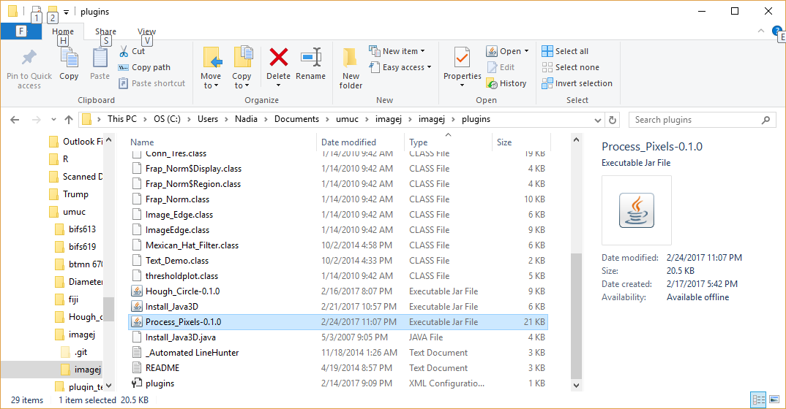

* 1. Copy the class files to the plugins directory

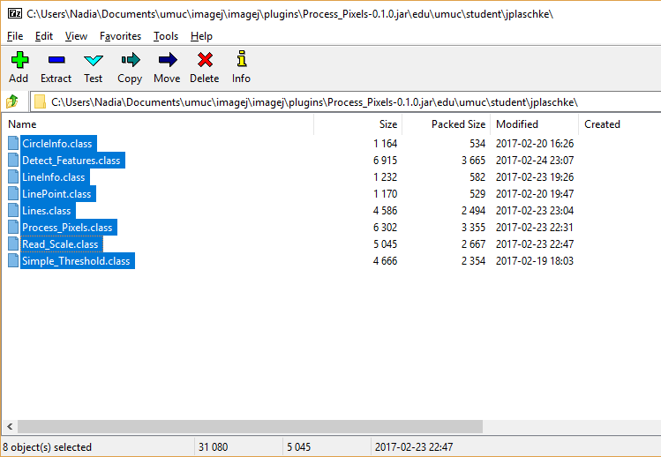

* 1. Right click and select “Copy to”
  2. Copy the class files to edu/umuc/student/jplaschke

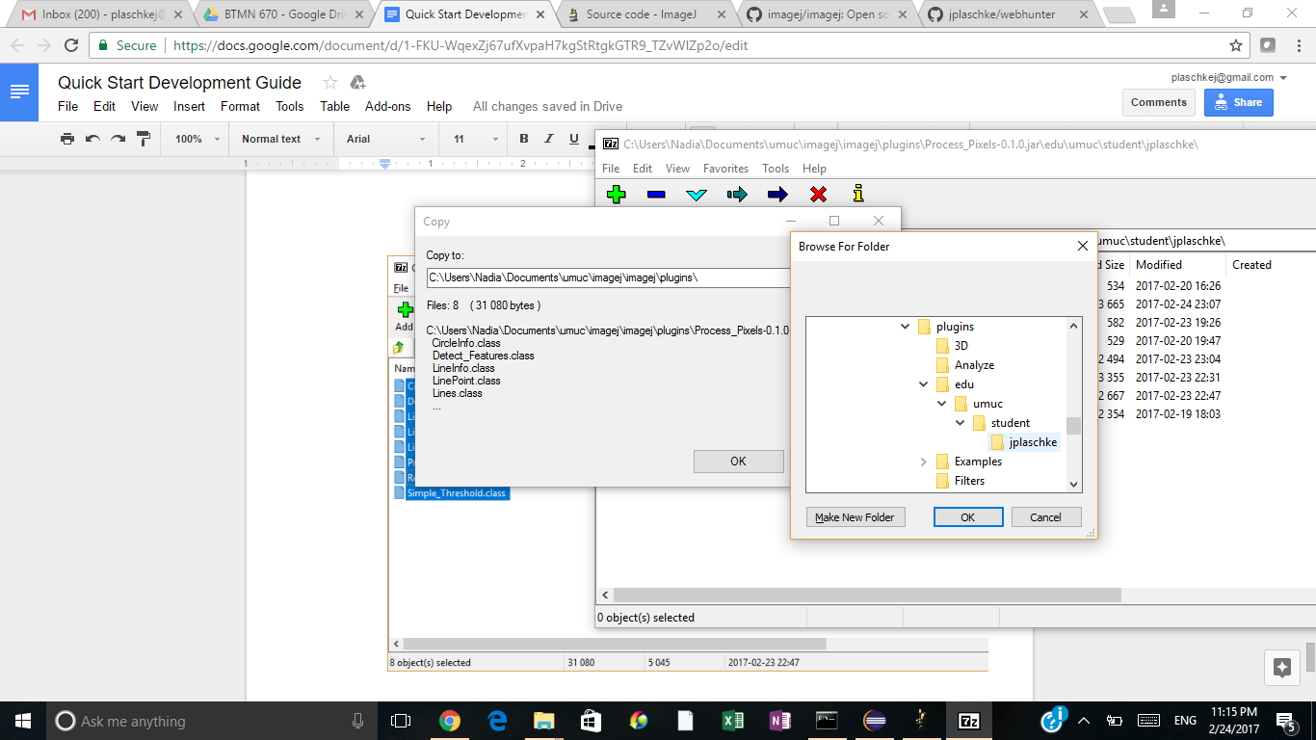

* 1. Run Process->Web Hunter

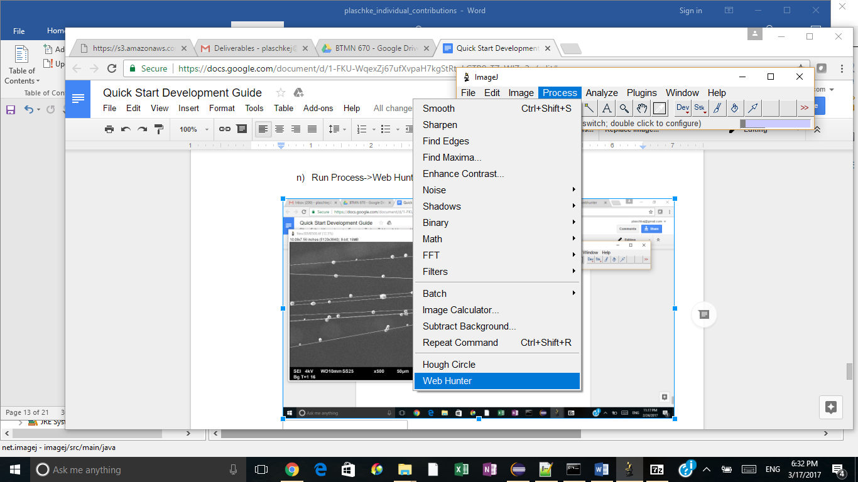

* 1. Input parameters

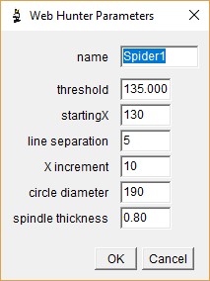

* 1. Select micrograph to process

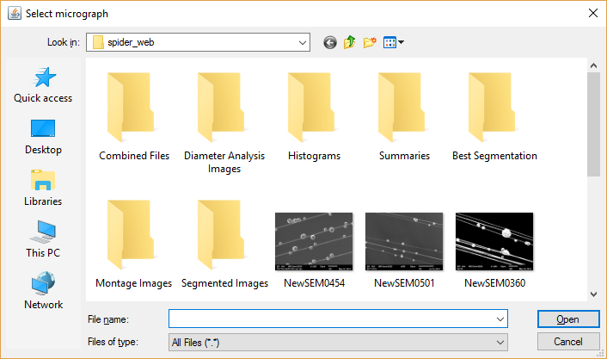

* 1. Show found lines

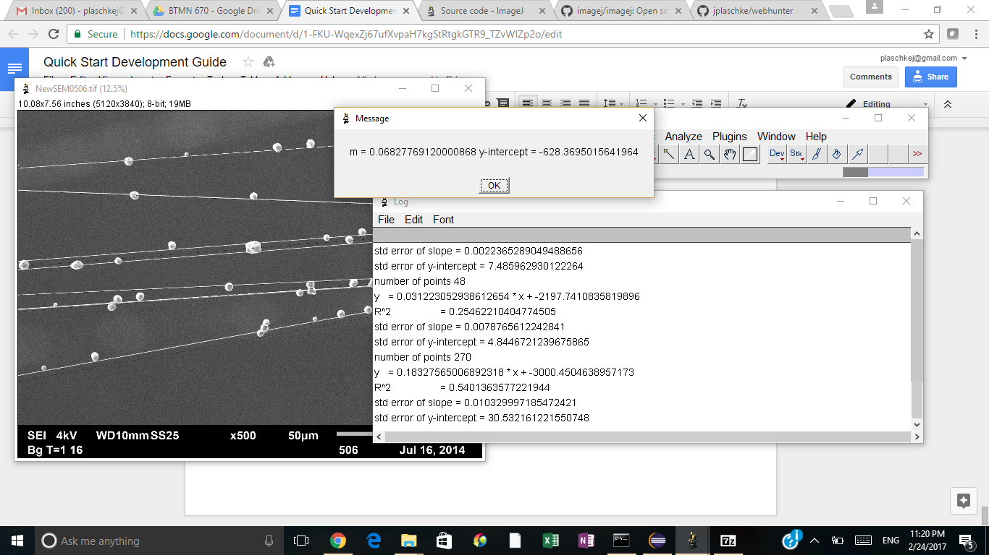

# Code Overview

Web_Hunter.java implements the plugin and is the “main” class. Processing starts in the run() method

Web_Hunter uses other classes to do various functions

1. Read_Scale.java - finds the scale information
2. Get SEM annotation information. This uses OCR to read the magnification and scale
3. Simple_Threshold.java - simple thresholding (unused) change to find histogram
4. Detect_Features.java - contains the code to detect lines and circles. Uses a simple state machine
5. Lines.java, LinePoint.java, LineInfo.java, CircleInfo.java - data structures to hold information about the lines and circles